**Ouroboros**

Self Eating Delay and Reverb Unit

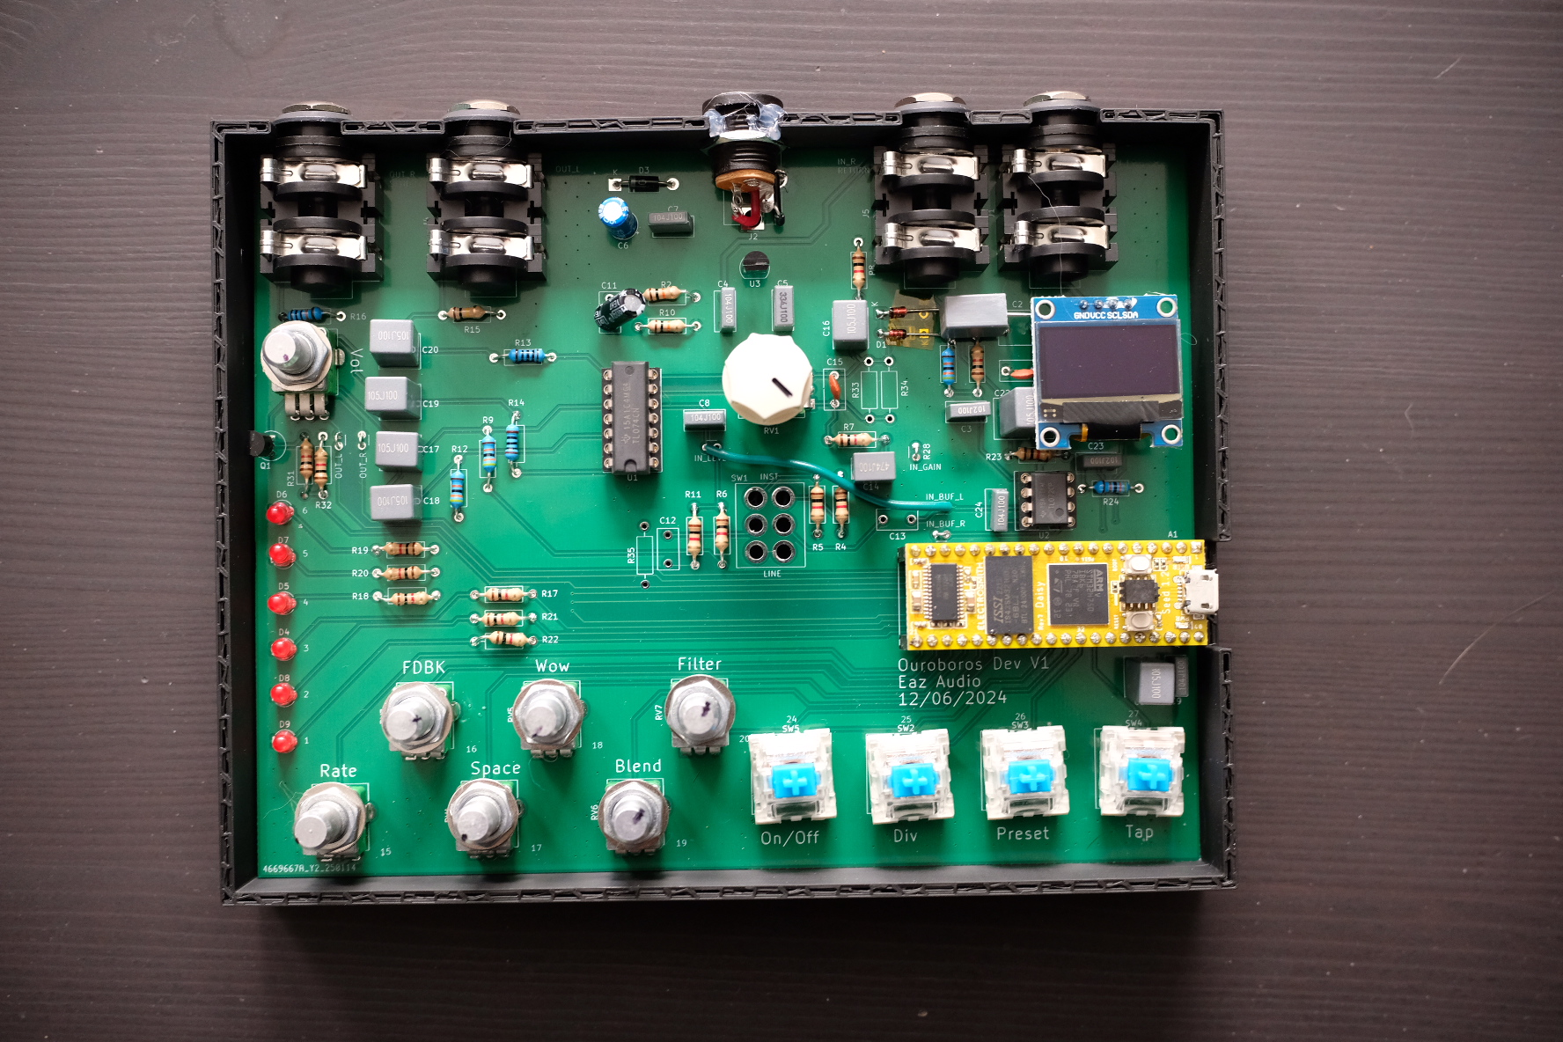

# Knobs

Rate: Changes the delay time  
FDBK: Adjusts how much feedback on the Delay and Reverb  
Space: Reverb Blend  
Wow: Removed and unused  
Blend: Delay Blend  
Filter: LP to the left, HP to the right, no filter when centered  
Vol: Volume out of the pedal  
Gain: Pregain into the pedal, wired backwards (Left is more gain)

# Buttons

On/Off: Turns delay on and off  
Div: Changes the division of the delay (delay time / division)  
Preset: Jumps between short, medium, long times  
Tap: Hit four times, tap tempo  
On/Off + Div: Changes the Input/Output mode (See Mode Section)

# LEDs

D6: On/Off  
D4: Tempo  
D3/D2: Mode Selection  
D5/D1: Unused

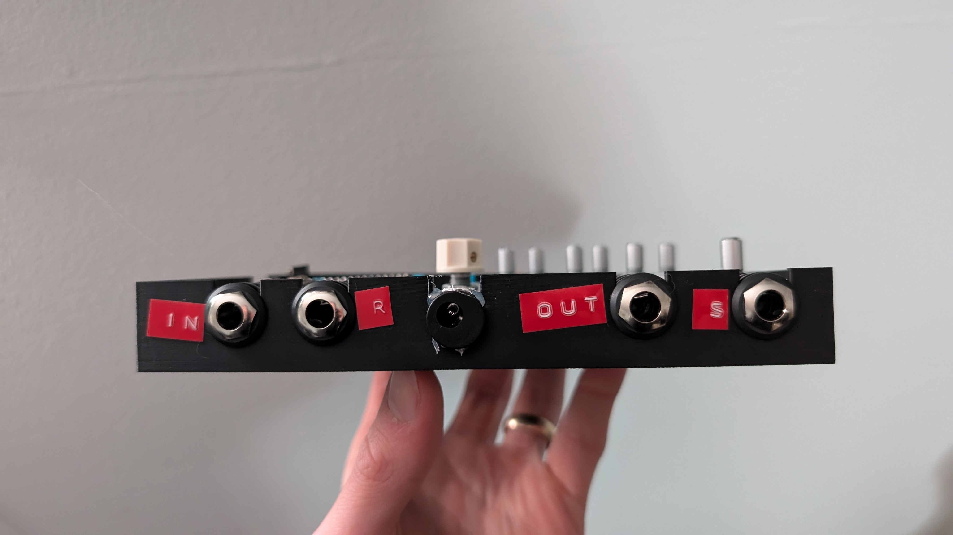

# Ports:

IN: Mono Input, Stereo Input Left  
R: Return Input, Stereo Input Right  
OUT: Mono Output, Stereo Output Left  
S: Send Output, Stereo Output Right  
DC Jack: 9V, center negative (normal guitar pedal power). Requires ~110mA

# Mode Selection

Mono (Mon): Use IN and OUT ports only. Delay Feedback is internal.   
Send/Return (S/R): Feed the S port into the input jack on another pedal(s), and the output of the pedal(s) into the R jack. Feedback from the delay is fed into your external pedal chain.  
Stereo(STR): Use IN and R as inputs, OUT and S as outputs. Delay Feedback is internal.

# Wiring Diagram